# **TABLE OF CONTENTS**

**TABLE OF CONTENTS** 1

**TABLE OF FIGURES** 2

**HARDWARE DESIGN CHANGES** 3

**ERROR IN 12V REGULATOR OUTPUT VOLTAGE** 3

**PROBLEM** 3

**SOLUTION** 3

**INCORRECT OUTPUT FROM FLYBACK TRANSFORMER** 4

**PROBLEM 01** 4

**SOLUTION** 4

**PROBLEM 02** 5

**SOLUTION** 5

**INCORRECT MAPPING OF SIGNAL AT INTERCONNECT** 6

**PROBLEM** 6

**SOLUTION** 7

**LED RESISTANCE MISSING** 8

**PROBLEM** 8

**SOLUTION** 8

# **TABLE OF FIGURES**

Figure 1 Image showing R41 and R38 swapped with each other 3

Figure 2 Image showing correct symbol (left) and incorrect symbol (right). Observe pin 4 and pin 6 of transformer 4

Figure 3 Diode placed manually on pin 6 (left) and pin 4 of transformer directly short with ISO_GND (right) 4

Figure 4 Formula for calculating Vout at the secondary of transformer 5

Figure 5 Formula for setting switching frequency of transformer to 300 KHz 5

Figure 6 Formula for calculating output at the secondary of transformer 3.8V 5

Figure 7 Error in mapping of interconnect signals 6

Figure 8 Image showing connection error with bottom PCB taken as correct reference 6

Figure 9 Image shows manual ribbon cable connections between Top and Bottom Board 7

Figure 10 Image showing values for calculating LED series resistance 8

# 

# **HARDWARE DESIGN CHANGES**

## **ERROR IN 12V REGULATOR OUTPUT VOLTAGE**

### **PROBLEM**

The first issue observed in the design was with the output of **DC DC Regulator U3** which was observed to be around **30V** when powered up whereas it was expected to be **12V** as per calculations. After investigation, it was discovered that the **FB pin was appearing as shorted to GND** thus causing same voltage as the **input to appear at the output**. The root cause of this was discovered to be a fabrication error where resistors **R38 and R41** were swapped during assembly process as can be observed in **Figure**

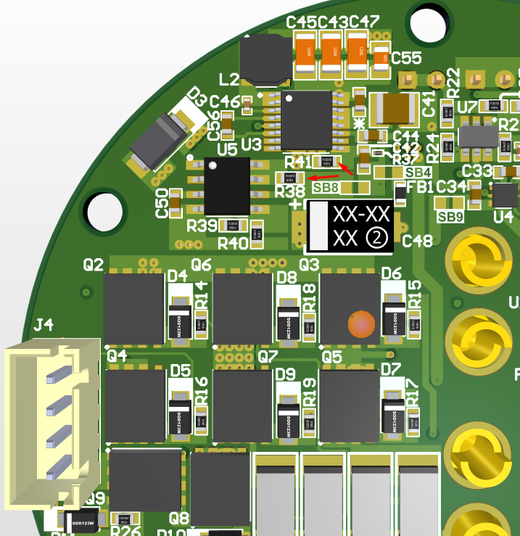

Figure 1 Image showing R41 and R38 swapped with each other

### **SOLUTION**

After swapping **R38 and R41** to their actual values, the output from U3 was then observed to be correct, measured at **12.4V**.

## **INCORRECT OUTPUT FROM FLYBACK TRANSFORMER**

### **PROBLEM 01**

The symbol and pin of **Transformer component 750314597** was found to be incorrect causing connections to be incorrect in the schematic.

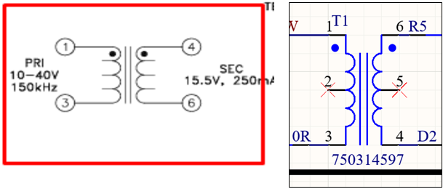

Figure 2 Image showing correct symbol (left) and incorrect symbol (right). Observe pin 4 and pin 6 of transformer

### **SOLUTION**

The other end of Resistor **R5 (0 ohms)** connected to **ISO_GND** was pulled out and connected to **3V8**. Similarly, the other end of **Diode D2** connected to **3V8** was pulled out and manually connected to **ISO_GND**.

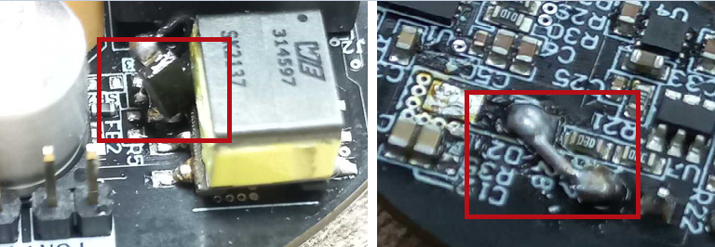

Figure 3 Diode placed manually on pin 6 (left) and pin 4 of transformer directly short with ISO_GND (right)

### **PROBLEM 02**

The next problem with this circuit was the feedback resistors were calculated incorrectly causing **8.66V** to appear at the output instead of required **3.8V**.

### **SOLUTION**

To obtain the required voltage at the output of the transformer, we need to include forward voltage drop of the secondary rectifier diode as mentioned in the datasheet. The voltage at the input of the transformer, if transformer with turns ratio of **1:1.5 (N1:N2)** is selected, is calculated to be **3.0V** according to the **Equation 22 Pg. 24 of the LM5160ADNTR** datasheet.



Figure 4 Formula for calculating Vout at the secondary of transformer

Following changes were made in hardware to achieve the desired output.

1. **Change R31 to 100KΩ** to set **Fsw to 300 KHz**, as we have set the output voltage to 3.0V at the primary side of the transformer. **LM5160ADNTR Datasheet Pg#19 Equation 12**.

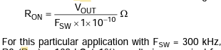

Figure 5 Formula for setting switching frequency of transformer to 300 KHz

1. **Change R4 to 7.8KΩ** for the feedback network to achieve 3.0V at the output on the primary side of the fly-back transformer. The transformer will then step up the voltage and provide the isolated 3.8V at the output.



Figure 6 Formula for calculating output at the secondary of transformer 3.8V

## **INCORRECT MAPPING OF SIGNAL AT INTERCONNECT**

### **PROBLEM**

The previous phase of prototypes saw the connections to be accurate but only the incorrect soldered in reverse manner due to overlay issue from designer. This was fixed in this version of prototypes but the connections weren’t mapped according to the new changes in symbol hence causing mismatching between the signals as can be observed in **Figure 7**.

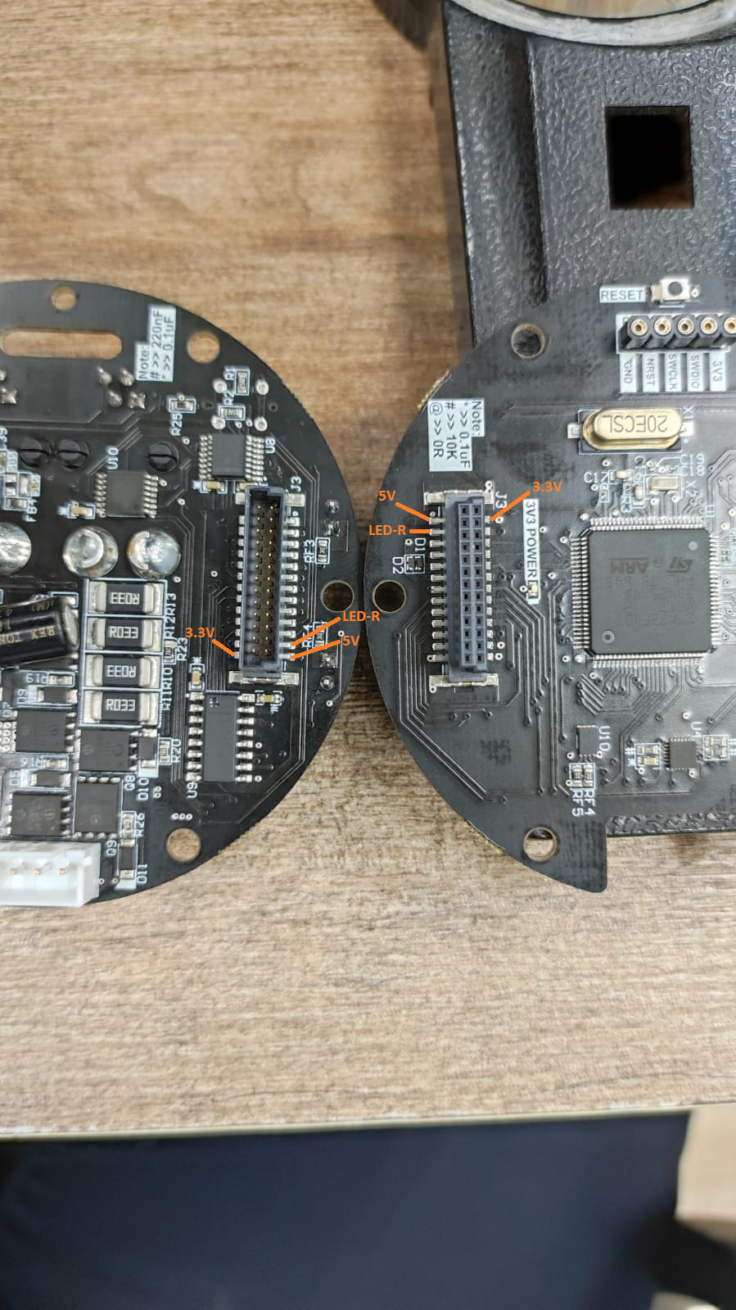

Figure 7 Error in mapping of interconnect signals

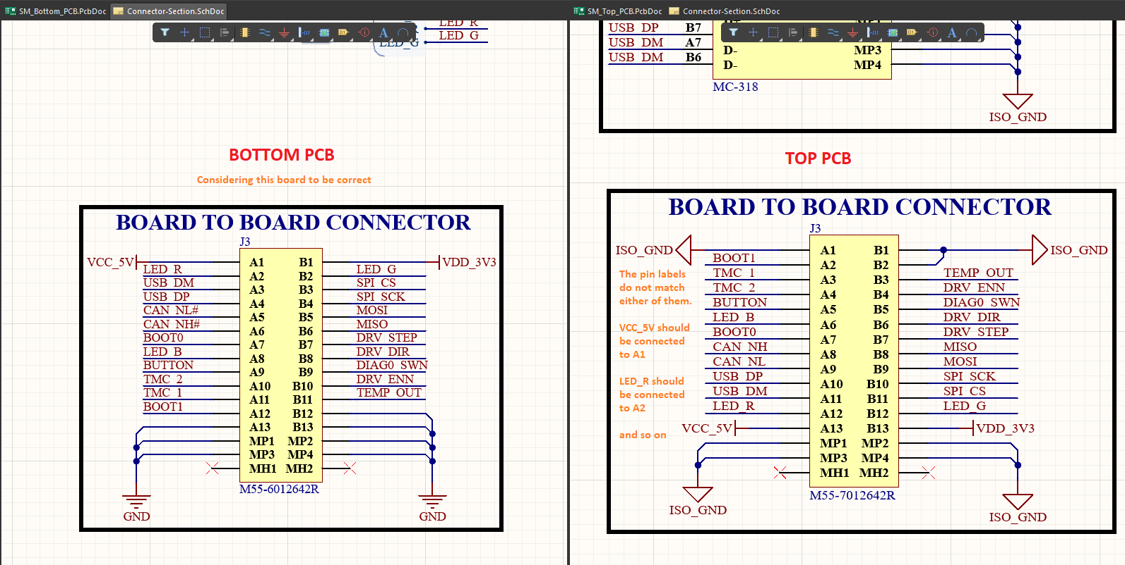

Figure 8 Image showing connection error with bottom PCB taken as correct reference

### **SOLUTION**

For the testing, the actual interconnects were removed from the board and a custom ribbon cable was manually soldered in the place to allow for further testing and proper connectivity between **Top and Bottom Board**

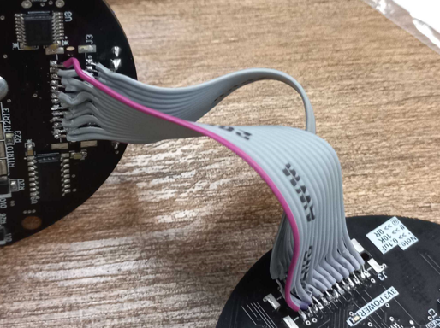

Figure 9 Image shows manual ribbon cable connections between Top and Bottom Board

## **LED RESISTANCE MISSING**

### **PROBLEM**

In the **RGB LED LTST-G683GEBW** on Top board, the current limiting resistor on the RED LED is missing.

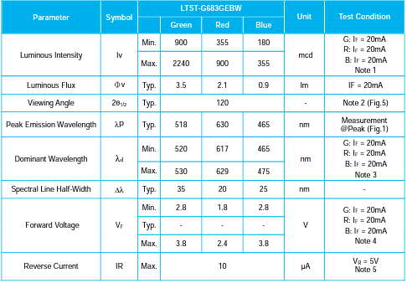

Figure 10 Image showing values for calculating LED series resistance

### **SOLUTION**

Add a resistor of **560Ω** to it. Only the RED LED is troublesome. The other LEDs are working fine and properly.